PLACE-BASED INQUIRY IN THE HIGH SCHOOL ENVIRONMENTAL SCIENCE CLASSROOM
by
Jake Phillips
A professional paper submitted in partial fulfillment
of the requirements for the degree
of
Master of Science
in
Science Education

MONTANA STATE UNIVERSITY
Bozeman, Montana
July 2024

©COPYRIGHT
by
Jacob Daniel Phillips
August 2024
All Rights Reserved

DEDICATION
To my wife, Lindsey, and daughters Sage and Luna: You three are the ones who drive me to be my best me. I will always love you.
To Mom, Dad, Barb, Chris, Barry, Denis, Caleb, Amanda, Ruby, Arianne, Kolby, Anna, Paul Dean, Emily, Leo, Cheryl, Tegan, Steve, Trudie, Grandma, Aunt Katie, Joel, Bo, Ethan, Brandon, Ackerman, Steve K., The Mistflower Gang (Matt & Kevin), Mr. Kevin Fisher, Dr. John Graves, Dr. Lisa Brown, Shannon Latimer, Kmson Kosam, and all my extended family and friends who still haven’t given up on me. I love y’all.

TABLE OF CONTENTS

1. INTRODUCTION & BACKGROUND 1

Context of the Study 1
Focus Statement 3

2. CONCEPTUAL FRAMEWORK 4

The Origins of Place-Based Education 4
The Benefits of Connecting Old School to New School 6
3. METHODOLOGY 10

Demographics 10
Treatment 12
Data Collection 13
St. Joseph, MO City Growth Lesson 13
The Jesse James Homestead Lesson 15
The History of Lake Contrary Lesson 17
The Nebraskan and Kansan Glaciers in Missouri Lesson 18
Corps of Engineer Involvement Lesson 20
Guest Speakers 1 & 2 21
4. DATA ANALYSIS 22

Results 22
The Jesse James Homestead Analysis 23
The History of Lake Contrary Analysis 24
The Nebraskan and Kansan Glaciers in Missouri Analysis 25
Corps of Engineer Involvement Analysis 26
Guest Speaker #1 Analysis 26
Guest Speaker #2 Analysis 27
Endgame Analysis 29
5. CLAIMS, EVIDENCE, AND REASONING 36
Claims From the Study 36
Value of the Study and Considerations for Future Research 38
Impact of Action Research on Author 39

REFERENCES CITED 42

TABLE OF CONTENTS CONTINUED

APPENDICES 45

APPENDIX A: Montana State University IRB Approval 46
APPENDIX B: Central High School Principal Approval 48
APPENDIX C: See-Think-Wonder Survey 50
APPENDIX D: Guest Speaker #1 Post-Presentation Survey 52
APPENDIX E: Guest Speaker #2 Post-Presentation Survey 55
APPENDIX F: Endgame Survey 58

LIST OF FIGURES
Figure Page

1. Historical image of Saint Joseph, Missouri, 1883 14

2. Contemporary image of Saint Joseph, 2019 15

3. Historical image of a famous house in St. Joseph, 1883 16

4. Contemporary image of the Jesse James House, 2023 16

5. Historical image of Lake Contrary Promotional Poster, early 1900s 17

6. Contemporary image of a flooded rollercoaster, 1954 18
7. Historical image of Missouri Glacier Limits Map 19
8. Contemporary image of NW Missouri along I-29 19
9. Historical image of the Platte River of Nebraska 20
10. An aerial view of St. Joseph, MO, looking North. 21
11. STW1 Comparison Data 22
12. STW2 Comparison Data 23
13. STW3 Comparison Data 24
14. STW4 Comparison Data 25
15. STW5 Comparison Data 26
16. Speaker #1 Frequent Responses 27
17. Speaker #2 Frequent Responses 29
18. PBE Connectivity Data 29

LIST OF FIGURES CONTINUED
Figure Page

19. PBE Additional Information Helpfulness Data 31

20. PBE Favorability Data 32

ABSTRACT
This project aimed to determine the effects of place-based education on a large American city high school environmental science classroom. Students engaged in learning about their physical location to gain a deeper understanding of high school environmental science. See-think-wonder primers and guest speaker pre- and post-content surveys were used as data collection instruments. Data was processed using qualitative and quantitative analysis strategies. The study's findings suggested that students gained content knowledge and a new understanding of the history and science that built the city and area they live in.

CHAPTER ONE

INTRODUCTION AND BACKGROUND

Context of the Study
I asked my high school environmental science class who Russell, Majors, and Waddell were, and I received blank stares from five of my six classes. In my final class, one student raised her hand and replied that she believed they had something to do with the Pony Express mail service. Correct. I do not expect people from outside of Saint Joseph, Missouri, to know the history of the Pony Express. However, when I polled 156 students, 155 of them said they had never heard of the three financiers of the Pony Express. This short-lived mail service, which used relays of horse-mounted riders, brought fame to our city and began right down the street from our high school.
Over the years, I have noticed that students appear more interested in the subjects that deal with issues that affect them specifically. This is when and where the concept of place-based education (PBE) comes into the equation. When the topic I am teaching involves the students, their neighborhoods, city, county, and state, the students almost always perk up. Four other teachers I polled at Central High School (CHS) also noted that their students almost always reengage in the discussion whenever they talk to students about local historical events, buildings, locations, and citizens of note.
I teach junior and senior-level environmental science at CHS in Saint Joseph, Missouri. Saint Joseph is a city of 72,000 people tucked into the Loess Bluffs of northwest Missouri and is located 50 miles north-northwest of Kansas City, Missouri, along the Missouri River. CHS is the largest of 21 Kindergarten to 12th Grade schools in the Saint Joseph School District (SJSD) and is one of the oldest high schools west of the Mississippi River. The SJSD population has over 11,000 enrolled students. The race/ethnicity populations of the SJSD are as follows: Caucasian - 81%, Hispanic or Latino – 7%, African American / Black – 5%, those of two or more races are 4%, Asian – 2%, and other - 1% (World Population Review, 2023).
As a city, 17.2% of the population of Saint Joseph is considered at or below poverty levels, which translates to 19 of the district’s 21 schools qualifying as Title 1 status. Title 1 is a United States federal education program that supports low-income students nationwide (Coral Cliffs Elementary, 2024). CHS alone has a government-funded reduced-price lunch population of 5.6%, while 46% of our students qualify for free lunch (World Population Review, 2023).
CHS has seven 50-minute class periods on a typical day, making for a speedy class. Attempting to add PBE to the already tight curriculum and schedule makes it challenging to teach regular science content. Still, as a science teacher, finding time to hold meaningful conversations about local science and historical events, complete laboratory exercises, and take field trips becomes difficult. We simply don’t have time to teach about the area in class. We expect students with extracurriculars and jobs to find time and money to see these compelling activities and events. It seems unreasonable to ask our students to find the time and money to go and learn independently in museums or natural areas, especially when nearly 52% of our students are on free or reduced lunch. This equation seems stacked against those who want to connect to their location.

Focus Question
What was the impact of using place-based examples on high school environmental science students?

CHAPTER TWO

CONCEPTUAL FRAMEWORK

The Origins of Place-Based Education
Place-based education (PBE) has many names in today’s educational environment. The names include land-based education, pedagogy of place, community-based education, local learning, experimental education, environmental education, service learning, etc. PBE is an approach to education that takes a regionally focused approach to engaging and educating the masses. Location-specific museums exist to inform visitors about a specific place and time. For example, The Patee House Hotel Museum in St. Joseph, Missouri, offers visitors the opportunity to imagine themselves in St. Joseph in the 1800s through large-scale exhibits such as walking the streets and seeing typical businesses, going to the train station, getting onto the train, and even seeing what hotel stays were like (Patee House Museum of Saint Joseph, 2024). Similarly, The Museum of the Rockies in Bozeman, Montana, provides visitors opportunities to gain experience through interactive paleontological and geological exhibits (Museum of the Rockies, 2024).
One study researched the impact of the PBE approach on high school social studies student achievement where students learned about the outdoors using PBE methods. The results found that student achievement and motivation improved across the board thanks to various outdoor activities and experiences connecting to social studies via local heritage, culture, and ecology (Yilmaz & Karakus, 2018). PBE integrates learning into the community, emphasizing individual growth, inquiry, and problem-solving. Using PBE to build students' worth and community matters because it helps address equity by providing all students with diverse learning opportunities, bridging gaps in access, and fostering a sense of belonging for students (Vander Ark, 2020). Additionally, PBE builds community by creating bonds, personalizing learning, building social networks, and promoting contribution. Thanks to PBE, school-age children can engage with their communities, foster community relationships, build communal equity, and view their community in an increasingly individualistic world (Liebtag et al., 2020).
While most museums have a substantial history of exploring place-based examples, integrating this approach into classrooms is recent. In the early 1990s, multiple studies advocated for place-based education and recognizing students' desire for greater cultural and ecological diversity. Bowers (1993) emphasized that we are not just physically present in places, but they shape us. This raises important questions for both students and educators about the relevance of their learning to their lives. For instance, in one school year, environmental science teachers in Missouri are expected to cover diverse topics including astronomy, geology, meteorology, ecology, and human impact (Missouri Department of Elementary & Secondary Education, 2024). However, the materials provided by the state rarely reference Missouri. Mannion (2011) argues that place-based education is crucial across generations. They contend that integrating place-based education effectively engages learners and conveys essential points.
Over the years, multiple disciplines have observed substantial PBE connections between teaching and learning. One study found that while PBE positively affected students’ learning about their place and time, many teachers had no access to such a curriculum (Hamilton & Polk, 2023). The teachers were given books in their discipline written by people tasked with using as large of an example lens as possible. A broad sweep approach was great for general learning, but what happened when students could not visualize a specific time and environment because of their upbringing? Should students of urban upbringing be expected to know the intricacies of agriculture? Should students of rural upbringing be expected to use urban or suburban concepts in the classroom? Polk and Hamilton (2023) agreed that using more place-based examples could alleviate the categorical differentiation of student learning.

The Benefits of Connecting Old School to New School
Gruenwald (2007) found positive effects of adding a critical place-based pedagogy through the curriculum. The study highlighted the need to move beyond the old school standard of a classroom that uses mass-produced textbooks relaying information with examples of places usually far from where the students are. The teachers involved in the project emphasized the need to incorporate what the students see, hear, and feel daily outside the classroom, and that finding the connection between the students and their world makes all the difference. The researcher explicitly called on educators to embrace a local-centric perspective that blends cultural contexts students understand with their environment. Later in a group piece, he found that using examples grounded in locality could help students foster a deeper understanding of the subject by connecting it to the people, places, communities, and cultures the students are a part (Gruenwald et al., 2007).
PBE has many different terms and defining traits, but Day (2020) defined PBE as utilizing local contexts as the foundation for classroom learning. For PBE to be successful, he stated that four concepts must first be achieved to substantiate their full learning potential: 1.) examples must have local context, 2.) must be student-centered learning, 3.) hands-on experiences must be had, and 4.) direct connections to the community are paramount. Day found that implementing PBE in his high school environmental science classroom was successful. Adding place-based education to his curriculum and classroom positively impacted student engagement, academics, and attitudes toward the local environment (Day, 2020).
While multiple studies have investigated the effect of place-based education on students, Smith & Sobel (2010) began by making it known that what distinguishes place-based and community-based education from regular education is the focus on learning experiences. To build this study, the authors created learning experiences to incorporate local issues or knowledge into the school’s curriculum while offering students the chance to do work that would help the community and the community’s view of the school. The authors found significance in adding place-based learning to the school curriculum by connecting classroom learning with real-life experiences of the school’s community (Smith & Sobel, 2010). The practical strategies discussed involve students in community projects, engaging with local partners, conducting field studies, and addressing community needs through service-learning opportunities. The study also highlighted examples of students at Kennedy High School who actively participated in various community improvement activities, which demonstrated the positive impact of place-based education on student empowerment and social change. In the end, the study also highlighted student-led examples that engaged and enhanced the community by conducting field studies, addressing community-specific needs, and spreading goodwill via service-learning opportunities (Smith & Sobel, 2010).
One such literature review firmly noted that interest and achievement reiterates that knowledge, positive emotion, and personal value are three key components of developing an interest (Harackiewicz & Hulleman, 2010). If the student is interested in improving their surroundings, this will lead to community involvement. Mutually beneficial partnerships delineated civic learning goals, reflective methodologies, and community-based learning endeavors. The PBE addition can seamlessly integrate across various educational tiers, simply by supplementing course materials to incorporate comprehensive projects into the curriculum (Rock, 2021). Aligning academic objectives with community imperatives from a geographic standpoint, students can confront contemporary societal issues and make meaningful contributions to their localities (Rock, 2021).
A large student body study asked faculty members of a downtown New York City school to redesign their courses to incorporate place-based learning activities to deepen student engagement and enhance general education outcomes. The study found that place-based learning increased student involvement, teamwork skills, questioning, and analyzing abilities (Goodlad & Leonard, 2003). Student questions and background knowledge are not seen as a body of prior knowledge to be corrected or built upon, but as a “foundation of learning” (Demarest, 2015). Students want to be involved in civic engagement, encouraging the faculty to revitalize their work. Despite facing challenges such as administrative requirements and students wishing to leave the campus, faculty observed a significant impact on pedagogy and student learning experiences across multiple disciplines thanks to the place-based approach (Goodlad & Leonard, 2003).
PBE has emerged as a transformative pedagogical approach in geography education, bridging the gap between classroom teachings and real-world applications. By forging partnerships with local nonprofit organizations, students establish connections with the local environment, natural landscapes, and the inhabitants. PBE underscores the significance of spatial citizenship in fostering robust community involvement and investigates how students' engagement with their immediate surroundings can enhance learning outcomes and student retention rates. This experimental method enriches students' comprehension of community-related issues and empowers them to utilize their expertise to improve society. Moreover, community-based learning underscores the pivotal role of citizenship in fostering effective community engagement while delving into the linkage students forge with their local surroundings, which in turn aids in bolstering learning outcomes and student retention. At the heart of the PBE framework lies the cultivation of spatial citizenship because PBE equips individuals with the ability to actively engage in community decision-making processes through spatial representations and a nuanced grasp of place by embedding spatially enhanced learning into the curriculum. Students can explore intricate global concepts at a grassroots level, fostering a more profound affinity with their environment, and honing their civic engagement capabilities (Rock, 2021).

CHAPTER THREE

METHODOLOGY

Demographics
This study aimed to determine whether my environmental science classes connected their community to learning. I wanted to know if place-based examples impacted my high school environmental science students. This study investigated how place-based inquiry, instead of traditional book-led inquiry, impacted high school environmental science classrooms. We implemented the place-based approach using examples from within the city limits of Saint Joseph, MO, and extended it to nearby relevant locations. Data collection involved surveys, interviews, and observations.
A total of 141 high school environmental science students aged 16 to 19 participated in the study. The only tracking information recorded about each student was their class hour, which placed them into one of two groups. No personal information, such as gender, race, religion, etc., was collected at any point. This study was conducted using the examples provided in the literature by the St. Joseph School District curriculum-approved textbook readings, assignments, projects, tests, and laboratory experiments; however, no grades were given. The research methodology for this project received an exemption from Montana State University’s Institutional Review Board, which exempted the research methodology for this project, ensuring compliance to collaborate with human subjects was maintained (Appendix A). Project exemption was also attained through the Saint Joseph School District Director of School Improvement, Dr. Kendra Lau, and Central High School Principal, Dr. Heather Renk (Appendix B).
Central High School is in Saint Joseph, Missouri, a city of 72,000 people nestled into the Loess Bluffs of northwest Missouri, situated 50 miles north-northwest of Kansas City, Missouri, along the Missouri River. CHS stood as the largest among 21 schools, from kindergarten to 12th Grade, in the Saint Joseph School District and is one of the oldest high schools west of the Mississippi River. SJSD reports a population of over 11,000 enrolled students. The racial/ethnic demographics of SJSD during the study period were as follows: Caucasian - 81%, Hispanic or Latino – 7%, African American / Black – 5%, those of two or more races - 4%, Asian – 2%, and other - 1%. At the time of the study, approximately 17.2% of the population of Saint Joseph is at or below poverty levels, resulting in 19 out of the district’s 21 schools qualifying for Title 1 status; Title 1, a United States federal education program, aimed to support low-income students nationwide (Coral Cliff Elementary, 2024). CHS alone had a government-funded reduced-price lunch population of 5.6%, while 46% of its students qualified for free lunch (World Population Review, 2023).
Through action research, I evaluated the influence of place-based examples on high school environmental science students. The six classes were divided into two groups: three hours of morning classes and three hours of afternoon classes. This study occurred during the second semester of the CHS’s 2023-24 school year. Ideally both groups would be identical but there was a noticeable difference in the behavior of the two groups. Seventy-one students made up the first group, comprised of the first three hours of my classes per day. This group appeared attentive and engaged with a higher assignment completion rate; it’s worth noting that the first group came to class before lunch. The second group comprised the final three classes per day and had 70 students who came to my class after lunch in the afternoon. The afternoon students seemed less involved, and the homework completion rate was significantly lower than those in the morning classes. At the end of semester 1, the morning group’s final environmental science grade averaged 93% (A-), while the afternoon average was 86% (B). It was determined that even though there were differences the two groups were comparable. All students were given a series of Google Forms surveys about their place-based education experiences. Surveys were collected with Google Forms because they are easy to create and share. The program transfers collected data to Google Sheets, and the program automatically creates charts and graphs depending on the needs collect qualitative, quantitative, or mixed data. The maximum number of students that filled out surveys was 118. Each survey was designed to address the focus question, What was the impact of using place-based examples on high school environmental science students?

Treatment
The treatment for this project was the way in which two groups of students were first introduced to the instructional content. One group was shown a contemporary image/photo prior to the content for a lesson containing lectures and discussions. To conclude the lesson, this group was then shown a historical image/photo pertaining to the lesson. The second group received the historical photo/image first, then the lesson and discussion, concluding with the contemporary image/photo. Surveys were administered that sought students’ observations, thoughts and wonderings about the topic. Each series of lessons included the pattern of either contemporary or historical image/photos first and ended with the survey. There were five different lessons: St. Joseph, MO city growth, the Jesse James homestead, the history of Lake Contrary, the Nebraskan and Kansan glaciers, and the Corps of Engineers involvement.

Data Collection
See-Think-Wonder surveys were used to assess each lesson (Appendix C). The surveys asked students three questions about each image: 1) What do you see? 2) What do you think? and 3) What do you wonder? The surveys were administered for each image/photo, creating a pre/post survey for each lesson, a total of 10 sets of survey data. Each survey was scored by assigning one point for student growth from pre to post survey based on teacher classroom observations. If students did not demonstrate growth, a score of zero was assigned. The same survey and scoring strategy was also used for two guest speakers and the final survey on Place-based Education.
The Guest Speaker Surveys were administered at the conclusion two guest speaker sessions (Appendix D). Each survey was scored by assigning one point for student growth from pre to post survey based on teacher classroom observations. If students did not demonstrate growth, a score of zero was assigned. The same survey and scoring strategy was also used for two guest speakers and the final survey on Place-based Education.
The Endgame Survey was used to assess the impact of the historical/contemporary image-driven lessons and guest speakers (Appendix E). Data from the survey was analyzed for themes and used as evidence to support other data sources.

St. Joseph, MO City Growth Lesson
The intent of this lesson was to look at the growth of downtown St. Joseph, Missouri and how the landscape has physically changed since its settling in the early 1800s. Per St. Joseph School District environmental science class curriculum, we discussed transitioning biomes, landscapes, and soils. The lesson used two images/photos of St. Joseph, MO to bookcase instruction, with one group receiving the history image to start the lesson (Figure 1) and a contemporary photo to end the lesson (Figure 2). The other group received the images in reverse order. The exact same content and discussion prompts were used for both lessons.
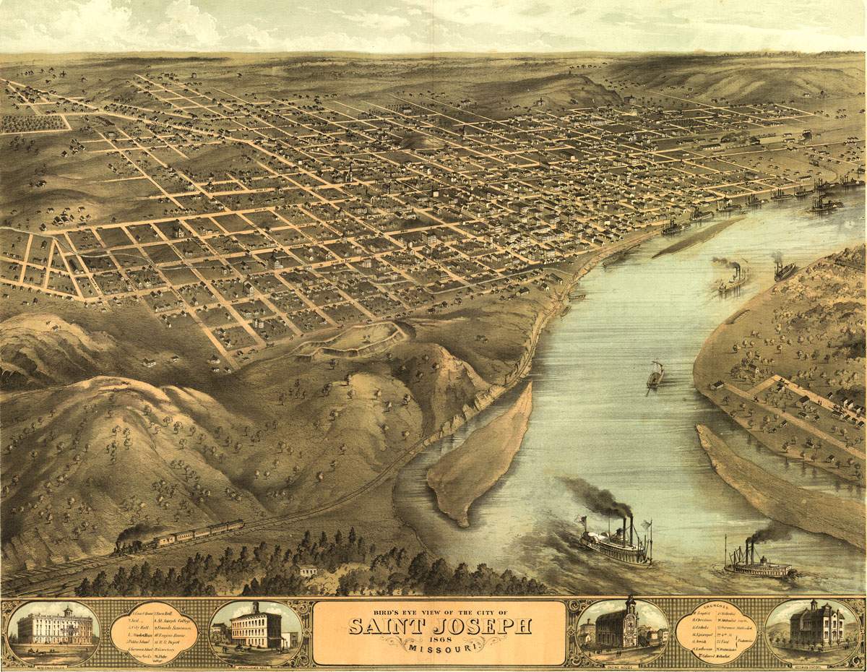
Figure 1. Historical image of Saint Joseph, Missouri, 1883.
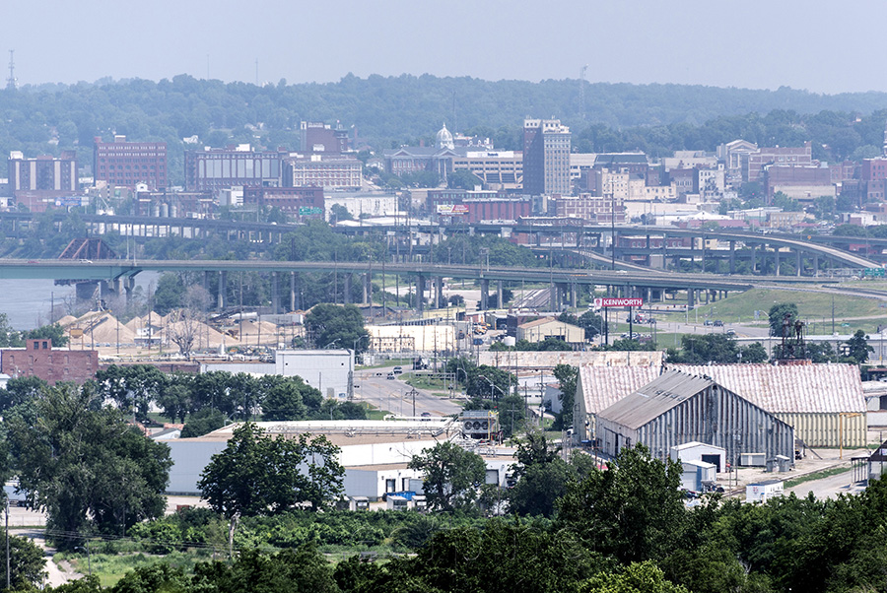
Figure 2. Contemporary photo of Saint Joseph, 2019.

The Jesse James Homestead Lesson
The intent of this lesson was to compare the historical and current locations of the Jesse James house through the change in the background landscape over time. The historical image (Figure 3) and contemporary photo (Figure 4) were used to bookend the lesson.
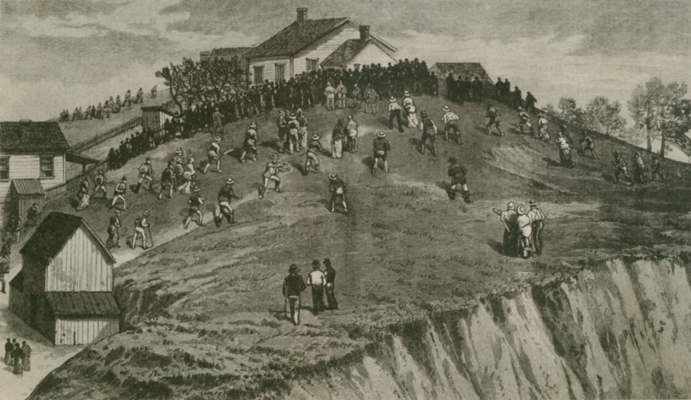
Figure 3. Historical image of a famous house in St. Joseph, 1883.
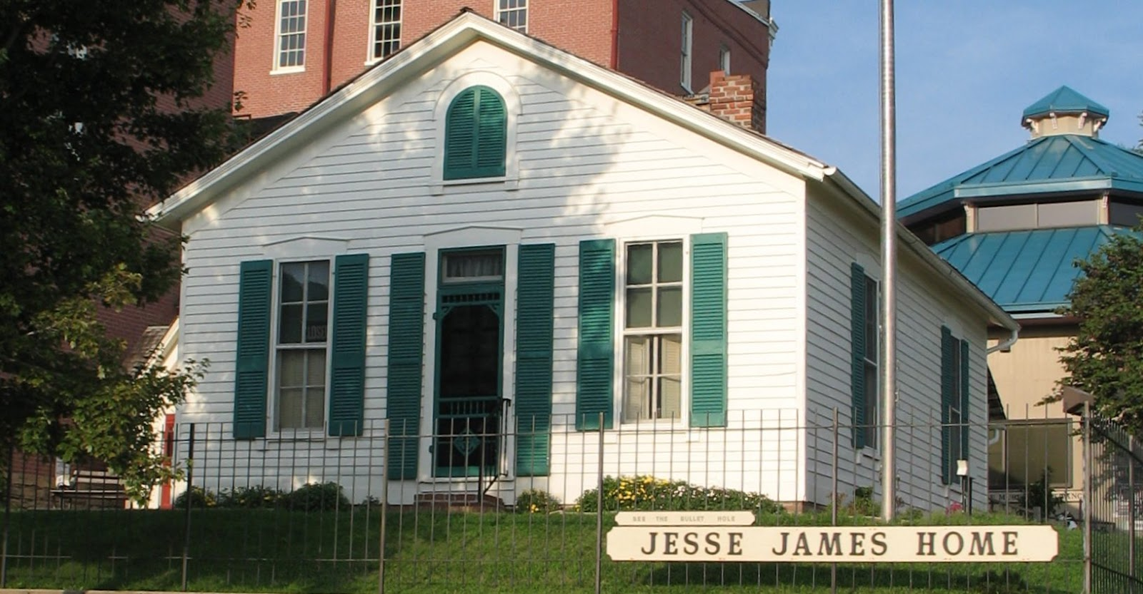
Figure 4. Contemporary image of the Jesse James House, 2023.

The History of Lake Contrary Lesson
The intent of this lesson was to compare changes of Lake Contrary, a local oxbow lake that was once popular as an amusement park. in landscape, river, or how both functions became exacerbated by the channeling of the river. The historical image (Figure 5) and contemporary photo (Figure 6) were used for the lesson.
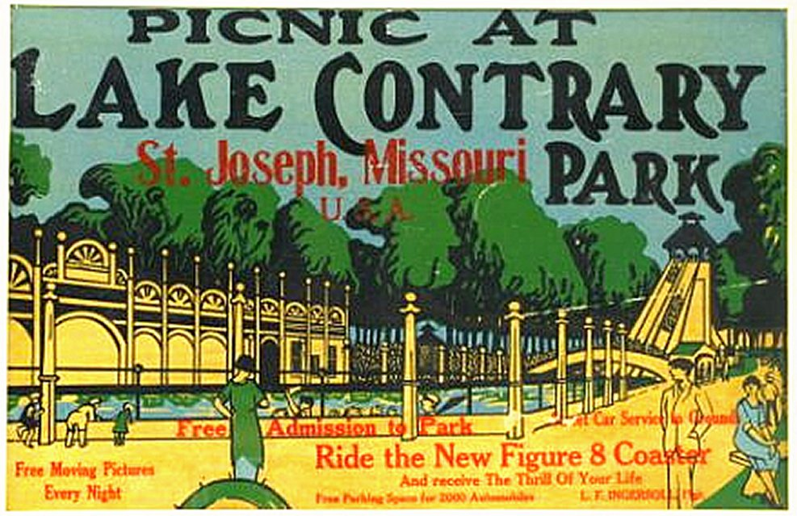
Figure 5. Historical image of Lake Contrary Promotional Poster, early 1900s.
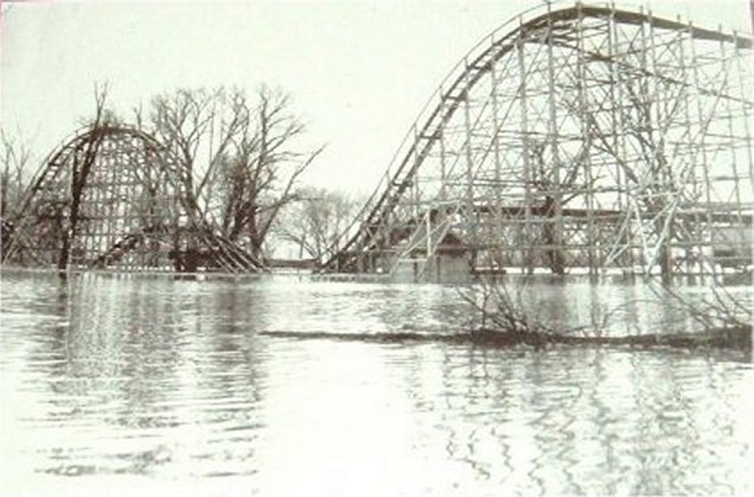
Figure 6. Contemporary image of a flooded rollercoaster, 1954.

The Nebraskan and Kansan Glaciers in Missouri Lesson
The intent of this lesson was to compare one chart of the limits of the last two significant glaciers that were in northwest Missouri with an image of how the glacially bulldozed hills look now. Figures 7 and 8 were used for this lesson.

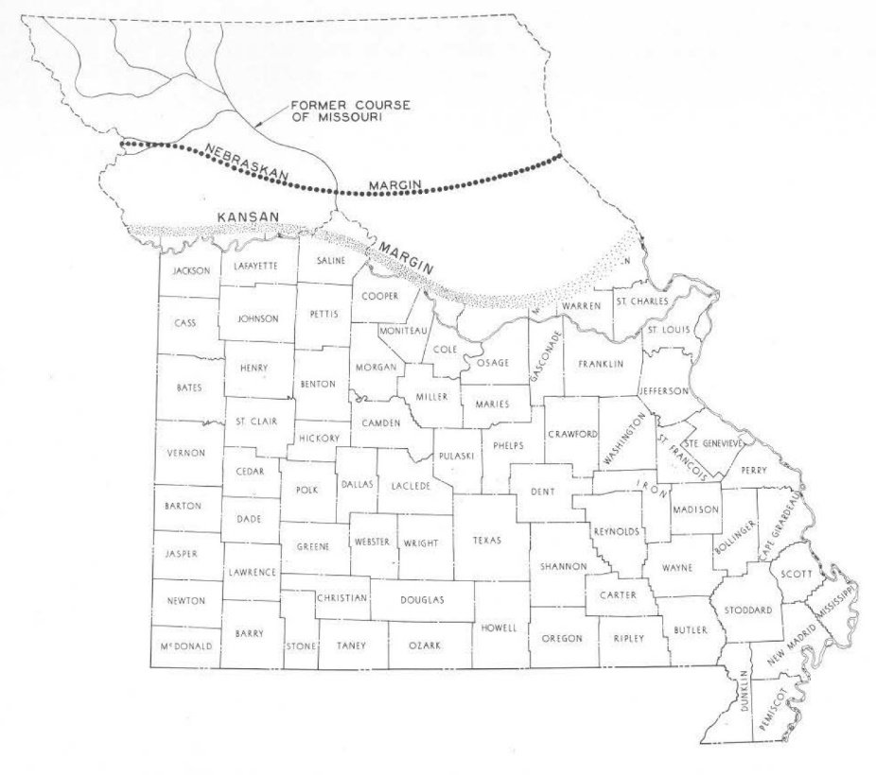
Figure 7. Historical image of Missouri Glacier Limits Map.
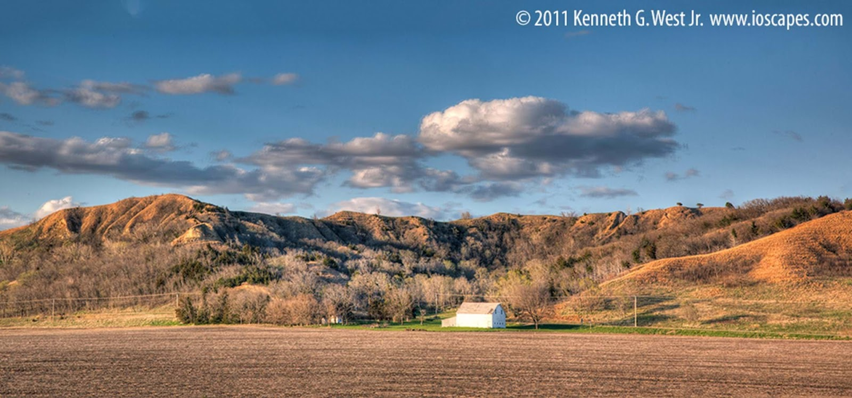
Figure 8. Contemporary image of NW Missouri along I-29.

Corps of Engineer Involvement Lesson
The intent of this lesson was to look at the historical and ecological change of the Missouri River and how the channeling of the river has altered what Midwest history could have been versus what it is. Figures 9 and 10 were used for this lesson.
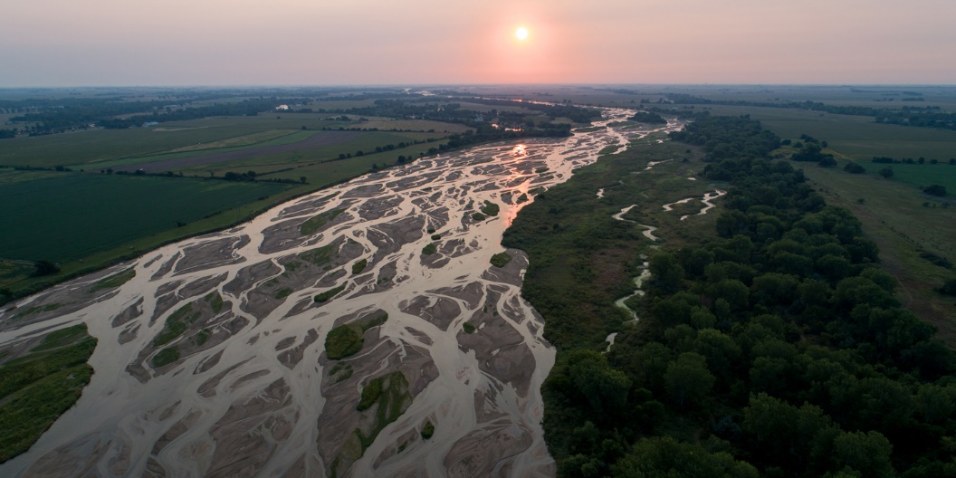
Figure 9. Historical image of the Platte River of Nebraska.
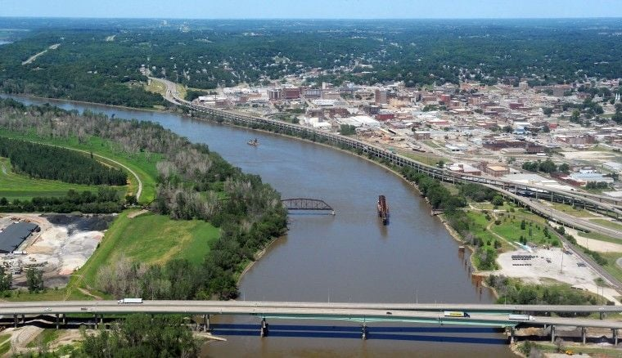
Figure 10. An aerial view of St. Joseph, MO, looking North.

Guest Speakers 1 & 2
The St. Joseph Museum communication director, Ms. Kami Jones, spoke to my classes about St. Joseph’s first city planner Jeffrey Deroine and other Black history of St. Joseph. The second guest speakers, Ms. Sara Wilson, the St. Joseph Museum Director and osteologist Ms. Tori Zeiger spoke to my classes to discuss the history and tribes of Native Americans of the Great Plains. Students completed the Guest Speaker Assessment after each presentation.
The Endgame Survey was used as the culmination survey to assess the impact of the use of contemporary/historical images to drive and conclude lessons and the guest speakers.

CHAPTER FOUR

DATA ANALYSIS
Results
The results of the See-Think-Wonder survey for the St. Joseph City Growth Lesson indicated that 68% of the students felt they understood the lesson better when shown the historical photo first. Seventy-six percent of the students said that seeing the contemporary photo first group helped them understand the lesson better (Figure 11). Students commented that they saw downtown and were disgusted, while others said the city has always been against historical growth and opportunity. One student said, “Nobody our age goes downtown. It’s gross and there’s nothing to do because the only events (the city) ever holds are for old people. I think they’re afraid of us trashing the place. The old people simply do not want us there and make sure of it. Who’s going to be downtown in the next 20 years though?”
Figure 11. STW1 Comparison Data. This shows answers students gave when asked if they thought the historical and contemporary photos helped them understand the lesson better.

The Jesse James Homestead Analysis
The results of the See-Think-Wonder survey for The Jesse James Homestead Lesson indicated that 79% of the students felt they understood the lesson better when shown the historical photo first. Sixty-seven percent of the students said that seeing the contemporary photo first group helped them understand the lesson better (Figure 12). Several students mentioned how they live close to this location as it is within CHS school boundaries. One said how hard it is to think of so much space between houses back then versus now. Multiple students of the morning group put together that the first picture must be Jesse James’ house in 1883. Multiple students then began chatting about the area around the building from the 1883 picture, specifically how the house sat on a sizable piece of grassland, the lack of trees, the open bluff, etc.

Figure 12. STW2 Comparison Data. This shows answers students gave when asked if they thought the historical and contemporary photos helped them understand the lesson better.

The History of Lake Contrary Analysis
The results of the See-Think-Wonder survey for The History of Lake Contrary Lesson indicated that 62% of the students felt they understood the lesson better when shown the historical photo first. Sixty-seven percent of the students said that seeing the contemporary photo first group helped them understand the lesson better (Figure 13). One student did not believe the amusement park was a real place in town. Four students wrote about talking to their grandparents about the amusement park. Some noted that they had seen this picture but couldn’t remember where, while a few said they had never been to the lake but had only heard of it. A student commented that they had seen the promotional photo in the Patee House Museum. Two students asked about the rollercoaster’s location, but most guessed it was near St. Joseph as that is what we had been talking about. I told them it was once at Lake Contrary. Several students struggled to recognize Lake Contrary as a part of the city, having enough water for recreation, etc.

Figure 13. STW3 Comparison Data. This shows answers students gave when asked if they thought the historical and contemporary photos helped them understand the lesson better.

The Nebraskan and Kansan Glaciers in Missouri Analysis
The results of the See-Think-Wonder survey for the Nebraskan and Kansan Glaciers in Missouri Lesson indicated that 71% of the students felt they understood the lesson better when shown the historical photo first. Forty percent of the students said that seeing the contemporary photo first group helped them understand the lesson better (Figure 14). Several students mentioned how they live close to this location as it is within CHS school boundaries. One said how hard it is to think of so much space between houses back then versus now. Multiple students of the morning group put together that the first picture must be Jesse James’ house in 1883. Multiple students then began chatting about the area around the building from the 1883 picture, specifically how the house sat on a sizable piece of grassland, the lack of trees, the open bluff, etc.

Figure 14. STW4 Comparison Data. This shows answers students gave when asked if they thought the historical and contemporary photos helped them understand the lesson better.

Corps of Engineer Involvement Analysis
The results of the See-Think-Wonder survey for the Corps of Engineer Involvement Lesson indicated that 75% of the students felt they understood the lesson better when shown the historical photo first. Seventy percent of the students said that seeing the contemporary photo first group helped them understand the lesson better (Figure 15).

Figure 15. STW5 Comparison Data. These are See-Think-Wonder Survey #5 Combined Data results. The question asked if the students thought the historical and contemporary photos helped them understand the lesson better.

Guest Speaker #1 Analysis
Ms. Kami Jones, communications director of the St. Joseph Museum, spoke to Groups A and B about historical figure Jeffrey Deroine. A total of 72 students completed the questions from the survey: Students were asked what parts of the presentation made a difference to them. Of the survey responses, 38% of students surveyed mentioned learning about Black history, 29% mentioned Jeffrey Deroine by name, and 15% replied that all parts of the presentation aided in their learning. Finally, 15% of students made comments that did not include any of the previous comments, and 3% gave no response (Figure 16).

Figure 16: Speaker #1 Frequent Responses, (N=72)
“I think everyone should learn about Jeffrey Deroine and the historical events of St. Joseph, no matter how hard it is to hear. None of what we learned today is what we’ve been taught.”, stated one student. Another student relayed, “Our history shaped our landscape and city, but this is the first time we’ve talked about it in school.” Finally, one student declared: “Until today, our Black History class was the only class we’ve ever talked about actual Black history outside of talking about the Civil War. Why did it take senior environmental science to learn what happened?”

Guest Speaker #2 Analysis

St. Joseph Museum Director Ms. Sara Wilson and lead archaeologist Ms. Tori Zeiger gave a presentation to the morning and afternoon groups. A total of 72 students commented on the post-presentation survey. The replies often mirrored the Jeffrey Deroine presentation comments, with several students seeming annoyed that they’ve not had classes that spoke so specifically about the area's indigenous peoples. Of the survey responses, 32% of students spoke of Indigenous people, customs, and history, 22% mentioned the Platte Purchase by name, and 15% made it known they wanted to learn more or wished they would have before now. Finally, 31% also commented but did not mention any of the above (Figure 17). One student said, “The Platte Purchase happened because of an invasive plant growing on King Hill?! What the Hell. That crap is all over my yard! Now I can’t look at it without thinking about how the Indians got screwed so bad.” Another student pointed out, “Yes, they need to learn about where certain things are from and what things looked like from back then. I’ve only ever seen trees everywhere and didn’t know this was a grassland.” Finally, a student said, “We should learn and go deeper into not just environmental science but go into our town’s history and the environment back then. This changes everything I’ve known about this town. How people act here makes total sense now.”

Figure 17: Speaker #2 Frequent Responses, (N=72).

Endgame Analysis
The results of the Endgame Analysis Survey indicated that 57% of those polled felt more connected to the community than they did before, while 39% feel indifferent, and only 4% feel less connected to the community than they did before we began PBE (N=115) (Figure 18).

Figure 18. PBE Connectivity Data. Student responses to the question: Do you feel more or less connected to the area? (N=115).
“I enjoyed talking about the Native American artifacts and differences between regional tribes. This place deserves a little more respect now,” commented a student. Another said, “I can’t help but laugh when I’m driving past (crossroad) now. I love that the soldiers got drunk and started shooting cannonballs into downtown.” A young man commented, “It’s cool that we get to mentally visualize the glaciers moving the soil here. It makes all the pink rocks I find make sense.” A surprised student wrote, “Wait, the Southend of town really was cool once? I liked learning about Lake Contrary because I grew up down there and my parents and grandparents would tell me stories. I thought they were just making stuff up.”
When asked if the addition of information about Saint Joseph/the area helped student learn environmental science better, 71% feel that the additional information taught helped them connect to our lesson with another 26% unsure if it did. Only 3% of students surveyed feel the additional details about St. Joseph and the area did not help them learn environmental science any better (N=118) (Figure 19).
“I have a bigger appreciation for the town even though it's still a small town, the history, and the environment means so much more to me. I think I have this bigger appreciation mainly because I'm also leaving for college soon and am going to miss the place I grew up,” wrote one student.

Figure 19. PBE Additional Information Helpfulness Data. Student responses to the question: Do you believe that additional information about the area helped you learn environmental science better? (N =118).

When asked if there was a moment during the learning about St. Joseph that made you feel a certain way, one student wrote:
Feelings can change for various reasons, such as new experiences, changes in circumstances, or personal growth. It's natural for feelings to evolve over time. If you're experiencing a shift in your feelings towards St. Joseph, it might be helpful to reflect on what's causing the change and how you want to move forward. This place usually sucks but this class (environmental science class) showed me that there is a side of the town I’ve never heard of, and I bet most of my classmates are learning it for the first time, too. Learning about Lewis & Clark, Jeffrey Deroine, “The Immortal Ten”, and the Natives showed me that this place has the potential not to be so bad. Of course, right as we’d graduate, we find out something cool about the town. Figures. It’s still cool to see what this town was, what it’s become, and now we’ve got a chance to make it better.
When students were asked if they felt more or less favorable about St. Joseph and the region as a result of the lessons, 49% said they felt more favorable about St. Joseph and the region after the treatments than before, with 47% reporting not feeling any different after the treatments than they did before. Only 4% felt the additional information about St. Joseph and the area made them like it less (Figure 20).

Figure 20. PBE Favorability Data. Student responses to the question: Do you feel more or less favorable about St. Joseph and the region now? (N=118).
When asked what, if anything, changed about how you feel about St. Joseph, one student wrote that “(St. Joseph) has got a lot more history than I knew. Before having the speakers come in, I didn’t really know much about our town or our state. I listened to them because it was very insightful for me. I love history, but for some reason I don’t know the history of the town or state I was born in. We always learn about the United States history, and I haven’t gotten to learn about Missouri in years, so it was nice hearing about our own little history and development. (This) has changed the way i see the city now because I have learned so many things and found out so many things about saint joe that I never knew.” Another student said, “I felt St Joseph was a small town and that it didn't have any history behind it but now I feel like it does have history and culture.”
When asked if adding local environmental and historical information helped students gain knowledge about ecological science better than being taught the subject without the additional information, 65% of the students believed place-based education-type instruction helped them learn the topics better. One student said, “What made the biggest impact to me was probably the talk about how the slave became free and owned some land and saved someone else and they lived happily ever after.” Another said, “I liked learning about all the Native American Tribes we had in this because I knew nothing about them before. Now I know they are here.”
Not everything the students commented on was positive. Many learned about how the city and its’ citizens have treated people and places “that didn’t matter” over the years. One learner commented, “I didn’t like that we talked about how the river used to look and how everyone used it. Now it looks terrible and it’s unusable. It’s really depressing.” A young woman commented, “I specifically liked learning about the Native Americans because we got to learn how they lived on the land, but it was horrible to hear how many times we took their land without them knowing.” Finally, one person typed, “I didn’t like finding out that the ‘founder’ of Saint Joseph was a slave owner and didn’t actually do anything to plot the city. [City founder Joseph Robidoux] was terrible and we treat him like he was some great person.” Another student said, “I kinda hated learning about St. Joseph and Missouri’s past, and how Blacks and Natives were treated, but also how we destroyed the land and never fixed it.” Some else wrote, “I hated all the racial conflict we’ve had here. It’s so engrained in the city’s being that we still see and hear it today.” One student also said, “My least favorite part was talking about the early, early history of St. Joe. This place sucks now because it founded by a horrible person and has sucked from the start.”
Looking at regional ecology, a learner said, “I felt sad hearing about our prairies that are at this point all but gone. It’s not just here but all over.” And another said, “I’ve never felt prouder to be from St. Joseph knowing more of our history but it also ashames me that we turned everything from grassland to farmland.” Other students brought up more about the overall feeling of St. Joseph now, “I just think how great the area used to be, and the potential that Saint Joe has always had but never did anything with, they just blamed and moved on.”
Commentors went on about the city’s founder: “I felt really angry when I learned Joseph Roubidoux didn't do hardly anything and had his slave do it all instead, with no credit. It makes me FURIOUS.” Another said, “About Joseph Robideaux, it pisses me off a racist slave owner is considered the founder when it was Jeffrey Deroine. That dude is total garbage.”
Regarding natives in the area, one student wrote, “Learning about the Indigenous tribes that lived around Saint Joseph was cool and more about Jeffrey Deroine was very touching. I had heard of Jeffrey before, but I never knew more than the fact that he had belonged to Joseph Robidoux. So, learning more about him made me very happy. On my mother's side, my great-grandmother was Cherokee. So, seeing my culture be represented was heartwarming.”
Overall feelings about learning about the area and its history when looking at ecology were mixed. One students said, “Honestly just throughout this unit I've been paying more attention to my surroundings when I go on walks and driving through downtown, and it's made me appreciate the scenery a lot more.” Another wrote, “I have a bigger appreciation for the town even though it's still a small town the history and the environment means so much more to me. I think I have this bigger appreciation mainly.” A third students commented, “[St. Joseph has] got a lot more history than I actually knew. Before having the speakers come in I didn’t really know much about our town or our state. Listening to them was actually very insightful for me. I love history, and I love the bluffs and the area, but for some reason I don’t know the history of the town or state, or the history of the land I was born on. We always learn about the United States history, so it was nice hearing about our own little history and development.”

CHAPTER FIVE

CLAIM, EVIDENCE, AND REASONING

Claims From the Study
From this study I can make the claim that students gained knowledge and appreciation of the topic and area when I used place-based examples (PBE) versus when I did not because these examples impacted them. Much of what I used to teach environmental science this year was rooted in place-based examples, even if I didn’t mean to. I know this because I taught more passionately, and multiple students told me it matters. Students told me that the passion I bring about the topic makes all the difference in the world, and my passion is the sciences of the environment and the adjacent history, geography, geology, and topography of the northwest Missouri area and beyond. I believe that students would still have gained knowledge if I had not used place-based examples, but the learning would be less impactful. The data overwhelmingly says that students gained a better understanding and appreciation of the topic and the related area whenever I use place-based examples. This result aligns with Rock's findings that establishing a seamless Project-Based education (PBE) connection between the curriculum and students' interests, civic learning goals, reflective methodologies, and community-based learning endeavors is essential. The survey results indicated that all three components were successfully met and reflected the study's findings (Rock, 2021).
From this study I can make the claim that place-based inquiry in the high school environmental science classroom worked better in my environmental science classroom as compared to typical book-led inquiry. The results were similar to those in Gruenwald et al.’s study which found that using local examples helps students understand the subject better by relating it to the people, places, communities, and cultures they belong to (Gruenwald et al., 2007). The place-based approach was implemented using examples within the city limits of Saint Joseph, MO, but extended to the nearest relevant location. I collected data via surveys, interviews, and observations. The data showed that this teaching method is effective for both the teacher and students by getting us mentally out of the classroom and into the community.
The study showed that several high school environmental science students learned better using PBE examples. The writer found that this was similar to Day’s work, which showed that incorporating place-based education into the curriculum and classroom positively impacts student engagement, academics, and attitudes toward the environment. Through class observations, I saw and heard students making connections from their lives to the geological and ecological portions of the Missouri high school environmental science curriculum to their homes. Student attitude and engagement almost always seemed better when using PBE than when not. Hearing high school students have conversations about environmental science themes in their own lives and neighborhoods positively affected my daily attitude, which also affected the students in that, and many times the next, class hour. PBE examples encouraged students to engage with the class and their home lives and using PBE gave us a common ground to talk about their local environment and other related happenings in the area. These findings were similar to those of Smith and Sobel, who emphasized the significance of integrating place-based learning into the school curriculum by linking classroom lessons with real-life experiences within the school's community (Smith & Sobel, 2010). One of the best things about PBE is that it gave the students and me the time and flexibility to talk and bond while discussing things outside of school, all while still being in school and discussing environmental science topics.

Value of the Study and Considerations for Future Research
Although statistical evidence regarding PBE via pre- and post-STW surveys was not always conclusive, evidence showed that overall student attitudes toward high school environmental science increased with PBE examples. I believe there were several problems at play with my questioning; One being that some of the wording of my questions on post-speaker surveys was not pointed enough to help collect data. I feel I chose the “How do you feel?” question too often rather than “Do you believe… (yes/no)?”. I believe more of this or that questioning would have brought more clarity to my students and my data collection. I also believe that the pictures I selected could have been better connected to the topic of the day. Also, rather than waiting for the class conversations to flow in the direction I wanted for data purposes, I didn’t use clearly connected images to get most students to link A and B as well as B and A.
Through this study I can make the claim that PBE isn’t nearly as convenient to teaching as reading a textbook because it takes time and effort on the teacher’s part. With that said, adding a face to the day’s lesson helped my research and to keep the lesson on track. PBE has become a fascinating medium for extending science teaching from the classroom to the community, city, state, and beyond. With advancements in technology and the ability to connect classrooms to locality, the examples of PBE are seemingly unlimited. In the future, I will spend more time looking for PBE examples with a more explicit connection between my curriculum and my community. Instead of looking for specific examples here and there, a more broad-stroke application would better suit my students and my teaching ability.
One of my biggest problems was simply getting the students to do the work. Over time, the word “survey” basically became a curse in my classroom because of the multitudes of surveys I asked my students to complete for zero points. I chose not to give grades for doing the surveys because I knew the IRB paperwork would cost precious data collection time and figuring out how and where to put points in the grade book for only a few students would be much more challenging. While going about my IRB as I did was less time-consuming and stressful for me, getting high school students to do a 3-question survey simply got more problematic as time went on because there was no grade incentive nor was there any type of punishment; it was merely me thanking them to do extra work.
If I were to do this study again, I would have done six STWs pairs and flipped the morning and afternoon STW image schedule after the third STW. I didn’t think about that until the study was nearly complete. The thing I noticed was that my morning STW tended to be a historical photo while the afternoons got a more contemporary photo. I would like to know how the morning would have done with the contemporary photo first and how the afternoon would have done with the historical photo first.

Impact of Action Research on the Author
I unknowingly began to investigate PBE about a decade ago. I noticed a significant gap in teaching 6th grade science standards compared to what rural northwest Missouri had when it came to connecting environmental, earth, and space science. The state standards I am told to teach often have a specific example, but the examples are often of something the students typically have no context with. While significant to scientists and easy to find by the textbook’s writers, most fitting examples seem irrelevant to the students because even the nearest place mentioned was hundreds of miles away. I know this because I look into their eyes as we learn together. Several years ago, I moved to teach high school environmental science and found that most geography has been thrown out the window after early middle school. I would have to describe a location or thing through my own memory with emotion attached to the mental image. It’s not fair to the students to expect them to understand something their teacher has seen and felt. \ How was I supposed to teach things we could only see on computers? Thankfully, place-based education fell into my lap.
Place-based education, while sometimes challenging to find connections, was when the pencil hit the paper for my classroom. I saw students start to understand what natural environmental science was. Studying PBE exclusively over the last two years has changed me as a classroom teacher, a parent, and a community member. All sorts of new avenues and adventures opened that have been in front of me the whole time: the Master Gardening Club of Missouri, Master Naturalists of Missouri, rock, gem, and mineral shows, the traveling Cold Blooded Expos for amphibian and reptile enthusiasts, and beyond. With my radar tuned so differently than before, I was introduced to much larger organizations at various universities that I otherwise might have never known were around. Examples of these are the Kansas State University Soil Lab and Tallgrass Prairie, the University of Missouri’s College of Agriculture, Food, and Natural Resources, the University of Kansas’ Biodiversity Institute, and even, Montana State University’s MSSE program.
PBE has become the path I needed to connect my classroom to the community, opening a new world many of my students might never have known existed. By investing in PBE, my classroom has transformed from connecting the dots of environmental, earth, and space science from a distance to showing that many of the same concepts are connected locally if you know where to look. I still believe that there are times when a traditional sense of study is best, but finding a way to connect our students to the world they live in, regardless of who or what they are outside the classroom, has shown me a unique new side of teaching. PBE has shown me that I should strive to find the best, most locally available ways to present complex information to my students. Shifting toward PBE has already helped me find that school and community connection spark I’ve been looking for.

REFERENCES CITED

Akkaya Yilmaz, M., & Karakuş, U. (2018). The impact of place-based education approach on student achievement in social studies. Review of International Geographical Education Online, 8(3), 500–516. https://doi.org/10.33403/rigeo.505261
Bowers, C. A. (1993). Education, cultural myths, and the ecological crisis: Toward deep changes. State University of New York Press, Albany, NY, p. 232.

Day, N. R. (2018). The impact of place-based education on student achievement, attendance, and environmental attitudes in a high school environmental science classroom. Montana State University.
Demarest, A. B. (2014). Place-based curriculum design: Exceeding standards through local investigations. Routledge. https://doi.org/10.4324/9781315795195
Goodlad, K., & Leonard, A. (2018). Place-based learning across the disciplines: A living laboratory approach to pedagogy. InSight: A Journal of Scholarly Teaching, 13, 150-164.
Gruenewald, D. A. (2003). The best of both worlds: A critical pedagogy of place. Educational Researcher (Washington, D.C.: 1972), 32(4), 3–12. https://doi.org/10.3102/0013189x032004003
Gruenewald, D. A., Koppelman, N., & Elam, A. (2007). "Our Place in History": Inspiring Place-Based Social History in Schools and Communities. The Journal of Museum Education, 32(3), 233-242.

Hamilton, E., & Marckini-Polk, L. (2023). The impact of place-based education on middle school students' environmental literacy and stewardship. Cogent Education, 10(1), 2163789. https://doi.org/10.1080/2331186X.2022.2163789

Harackiewicz, J. M., & Hulleman, C. S. (2010). The importance of interest: The role of achievement goals and task values in promoting the development of interest. Social and Personality Psychology Compass, 4(1), 42–52. https://doi.org/10.1111/j.1751-9004.2009.00207.x

Mannion, G., & Adey, C. (2011). Place-Based Education Is an Intergenerational Practice. Children, Youth and Environments, 21(1), 35-58.

Missouri Department of Elementary and Secondary Education, Missouri. Retrieved June 4, 2024, from https://dese.mo.gov/
Museum of the Rockies, Bozeman, Montana. Retrieved June 4, 2024, from https://museumoftherockies.org/.

REFERENCES CITED CONTINUED
Patee House Museum of Saint Joseph, Missouri. Retrieved June 4, 2024, from http://ponyexpressjessejames.com/.

Rock, A. E. (2021). Bringing geography to the community: Community-based learning and the geography classroom. GeoJournal, 87(Suppl 2), S235-S247.

St. Joseph, Missouri population 2023. World Population Review. Retrieved April 19, 2024, from https://worldpopulationreview.com/us-cities/st-joseph-mo-population.

Smith, G. A., & Sobel, D. (2010). Bring it on home. Educational Leadership: Journal of the Department of Supervision and Curriculum Development, N.E.A, September 2010.

The River of Lewis and Clark. Missouri River Water Trail. Retrieved January 8, 2024, from https://missouririverwatertrail.org/river-history/river-lewis-and-clark

Title One – Coral Cliffs Elementary. (n.d.). Cces.washk12.org. Retrieved May 3, 2024, from https://cces.washk12.org/title-one/
Vander Ark, T., Liebtag, E., & McClennen, N. (2020). The power of place: Authentic learning through place-based education. Association for supervision of Curriculum Development. Retrieved from https://www.perlego.com/book/3292483/the-power-of-place-authentic-learning-through-placebased-education-pdf

APPENDICES

APPENDIX A
MONTANA STATE UNIVERSITY IRB APPROVAL
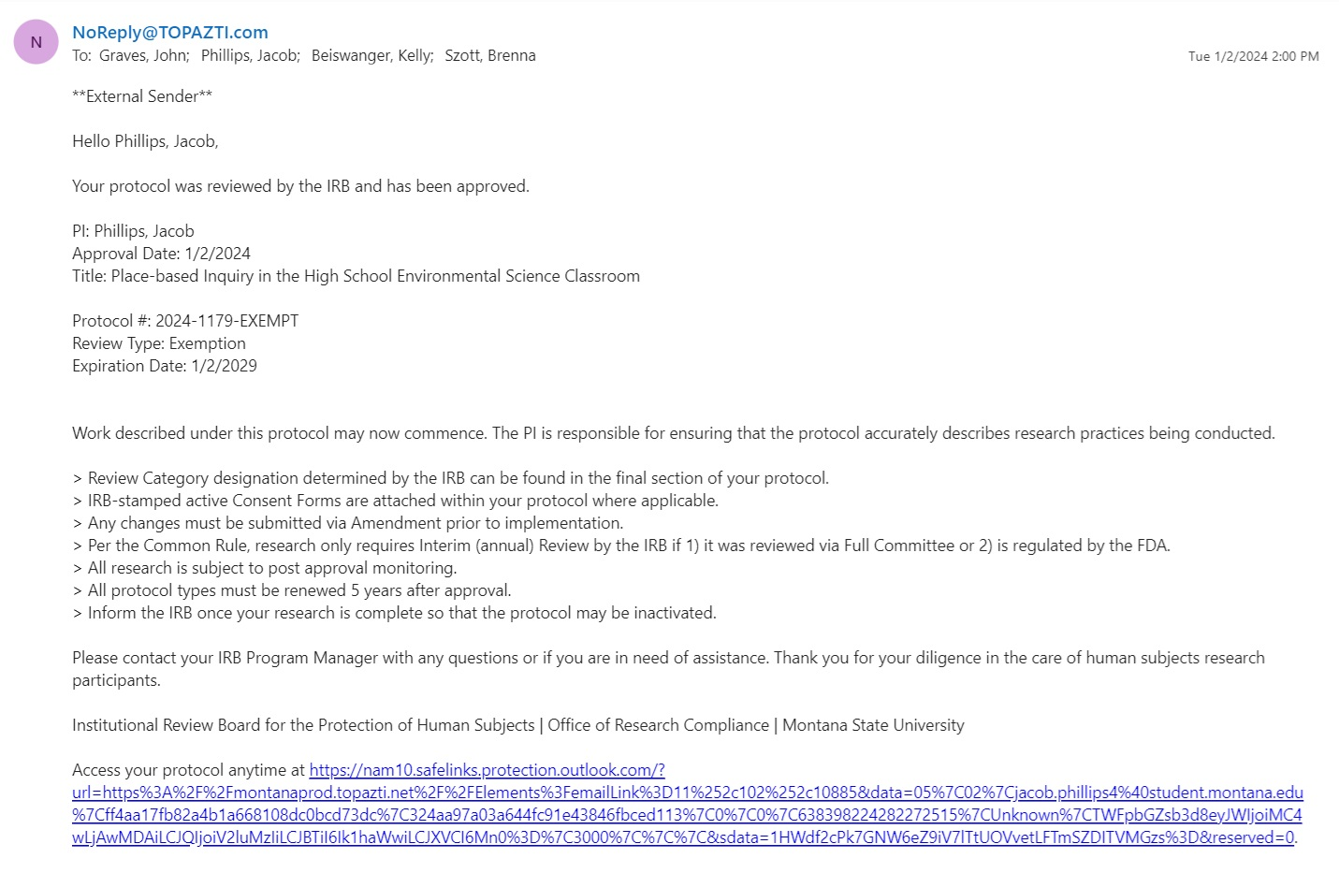

APPENDIX B
CENTRAL HIGH SCHOOL PRINCIPAL APPROVAL
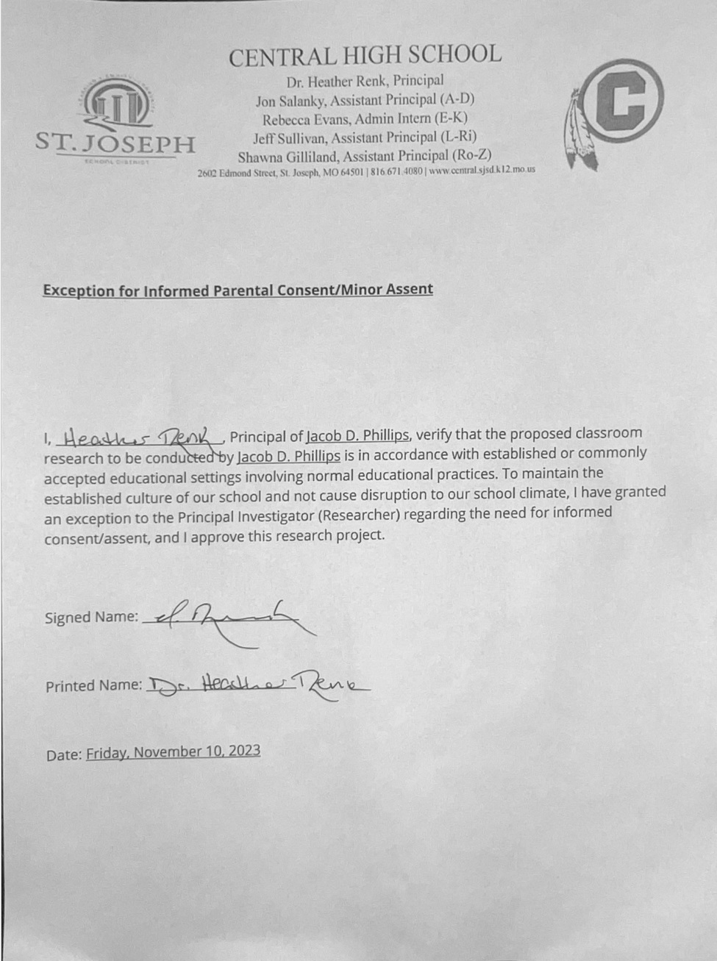

APPENDIX C
SEE – THINK – WONDER SURVEY

See – Think – Wonder Date: ___________________
Directions
First, look at the picture on the screen and write down what it is in question 1.
Next, please answer questions 3, 4, & 5 to the best of your abilities.
1.) Which of Mr. Phillips’ groups are you in? (Circle One)
Morning (1st, 2nd, & 3rd Hours) Afternoon (5th, 6th, & 7th Hours)
2.) What number and letter of S-T-W did Mr. Phillips post on the screen before the image?
3.) Using the image on the TV, what do you see? What sticks out to you the most?

4.) Using what you “see” on the TV image, what do you think is going on?
5.) What does the image make you wonder?

APPENDIX D
GUEST SPEAKER #1 POST-PRESENTATION SURVEY

Guest Speaker #1 Post-Presentation Survey Date: ___________________
1.) How much did you enjoy (name) of Saint Joseph Museum?
(Please circle only one number.)
1 2 3 4 5
(That was not great.) (That was great!)
2.) What was your favorite part of the talk?
3.) What was your least favorite part of the talk??
4.) Did you find any of the topics (name) spoke about today confusing?
If YES, proceed to question 5.
If NO, skip question 5 and go to question 6.
5.) If yes, what was confusing?

6.) Did this talk make you want to go to the Saint Joseph Museum?
7.) Did this presentation make you want Mr. Phillips to bring in more presenters?
If YES, proceed to question 8.
If NO, skip question 8 and go to question 9.
8.) If you answered "yes" to question 7, whom would you like to hear from and what field do they work in?
9.) Have any of your teachers ever had guest speakers?
If YES, proceed to question 10.
If NO, skip question 10 and go to question 11.

10.) If you answered "yes" to question 9, do you remember who they were and why they came to talk? This can be at any grade of your schooling, outside of school groups, athletics talking to a team, etc.

11.) Let's say some of your other environmental science classes were not getting the speaker you had. Was there anything you learned that you believe Mr. Phillips' other environmental science classes should learn?
12.) 12. On a scale of 1-5, how eager would you be to have our speaker, (name) the director of the Saint Joseph Museum, return?
1 2 3 4 5
(Not interested.) (Please stop by any time!)

APPENDIX E
GUEST SPEAKER #2 POST-PRESENTATION SURVEY

Guest Speaker #2 Post-Presentation Survey Date: ___________________
1.) How much did you enjoy (name) of Saint Joseph Museum?
(Please circle only one number.)
1 2 3 4 5
(That was not great.) (That was great!)
2.) What was your favorite part of the talk?
3.) What was your least favorite part of the talk??
4.) Did you find any of the topics (name) spoke about today confusing?
If YES, proceed to question 5.
If NO, skip question 5 and go to question 6.
5.) If yes, what was confusing?
6.) Did this talk make you want to go to the Saint Joseph Museum?
7.) Did this presentation make you want Mr. Phillips to bring in more presenters?
If YES, proceed to question 8.
If NO, skip question 8 and go to question 9.
8.) If you answered "yes" to question 7, whom would you like to hear from and what field do they work in?
9.) Have any of your teachers ever had guest speakers?
If YES, proceed to question 10.
If NO, skip question 10 and go to question 11.

10.) If you answered "yes" to question 9, do you remember who they were and why they came to talk? This can be at any grade of your schooling, outside of school groups, athletics talking to a team, etc.

11.) Let's say some of your other environmental science classes were not getting the speaker you had. Was there anything you learned that you believe Mr. Phillips' other environmental science classes should learn?
12.) 12. On a scale of 1-5, how eager would you be to have our speaker, (name) the director of the Saint Joseph Museum, return?
1 2 3 4 5
(Not interested.) (Please stop by any time!)

APPENDIX F
ENDGAME SURVEY

Your Final Overall Feelings of Learning about St. Joseph (Endgame)
1.) Did you enjoy learning about the history of St. Joseph and the area?
Yes No Indifferent

2.) Do you feel more or less connected to St. Joseph and the area now?
More Connected Indifferent Less Connected

3.) Do you believe that the addition of information about Saint Joseph / the area helped or will help you learn Environmental Science better?
Yes No Unsure
4.) What was your favorite St. Joseph or regional thing we've talked about?
5.) What was your least favorite St. Joseph or regional thing we talked about?
6.) Was there a moment during our learning about St. Joseph that made you feel a certain way? Please elaborate if you are able.
7.) Did the speakers make you want to go to the St. Joseph Museum?
Yes No
8.) Do you feel more favorable or less favorable about St. Joseph and the region now?
More Favorable Indifferent Less Favorable
9.) What, if anything, changed about how you feel about St. Joseph?

